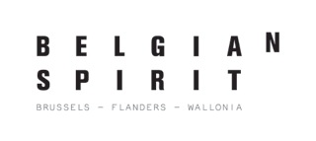
Brussels Invest & Export – Flanders Investment & Trade – Wallonia Foreign Trade and Investment Agency (AWEX)
Press Release
December 8th, 2012

Belgium elected partner country at Business of Design Week 2013 in Hong Kong

Ever since 2002 Business of Design Week (BoDW – www.bodw.com) has been the annual showcase for the creative sector in Hong Kong, Asia’s top creative hub. This comprehensive event, featuring dozens of seminars, exhibitions, workshops and a trade show, attracts close to 100,000 visitors from all over the world. Architects, designers and other creative people attend the event to get inspired, to network, and to check out China's business potential and do actual business.
Professional visitors see the enormous added value that BoDW can offer. The sheer variety of events and activities, combined with the presence of tens of thousands of like-minded professionals young and old, makes BoDW very attractive to anyone interested in doing business in the region. Add to this a whole series of big names who, year after year, come to speak and share their experience with visitor (incl. Frank Gehry, Kenzo Takada, Tadao Ando, Zaha Hadid, Philippe Starck, Naoto Fukusawa, Vivienne Tam, Antonio Citterio, Bjarke Ingels, Piero Lisoni, Dieter Rams) and you have the recipe for an absolute success formula, with a global business impact on the creative sectors.
Every year, BoDW organizer Hong Kong Design Center (HKDC) selects a partner country, which provides content and speakers for up to one third of the overall program. For the partner country this means substantially more exposure at the seminars, exhibitions and the trade fair.
After two years of behind-the-scenes preparations Belgium was chosen as partner country for BoDW 2013 under the name of “Belgian Spirit”.
“Belgian Spirit” was set up in 2011 by the three Belgian regions of Brussels, Flanders and Wallonia to jointly promote Belgium’s strong tradition of creativity, innovation, design, technology and innate talent. It is a collaborative effort of Wallonia Foreign Trade and Investment Agency, Brussels Invest & Export, Flanders Investment & Trade, Design Flanders, Design Platform Flanders, Flanders DC, Flanders Fashion Institute, Flemish Architecture Institute, MAD Brussels (Centre for Fashion and Design), Wallonie-Bruxelles Design/Mode and Wallonie-Bruxelles Architectures.
Belgian Spirit aspires to internationalize Belgian creativity even more than it already is, and it is focused on creating and developing a long-term collaboration platform with Business of Design Week in Hong Kong. The aim is to re-inforce the creative, cultural and economic ties between the professionals in the Architecture, Design and Fashion sectors of both countries.
On top of contributing to the overall program of BoDW 2013, Belgian Spirit will organise its own activities next year, including seminars and workshops about fashion, design, architecture, and other sectors. We will also develop wide variety of exciting events that are aimed at introducing all aspects of Belgian design, including food design, to the people of Hong Kong and Asia.
Belgium's selection as BoDW partner country is a clear acknowledgement by BoDW’s organisers of Belgium’s importance in the global world of creativity. Naturally, with creative people who have already made a name for themselves on the international scene in the fields of architecture (e.g. Office, Robbrecht & Daem, JDS Architects and Besix), fashion (i.a. Raf Simons, Kris Van Assche, Dries Van Noten, Walter Van Beirendonck, A.F. Vandevorst, Anne Demeulemeester, Tim Van Steenbergen, Delvaux, Jean-Paul Knott, Jean-Paul Lespagnard, Sandrina Fasoli, Carine Gilson), industrial design, product design, and culinary design (e.g. Maarten Van Severen, Dirk Wijnants, Tribu, Arne Quinze, Hoet brillen, Pierre Marcolini, Luc Donckerwolcke, Dirk van Braekel, Pierre Leclerq, Xavier Lust, Charles Kaisin, Alain Berteau, Luc Vincent, Alain Gilles, Nathalie Dewez, and Lowie Vermeersch), such recognition does not come as a surprise to us. Instead, it is a confirmation of our belief that the creative community in Belgian is doing an admirable job in showing the world what Belgium is capable of.
On November 1st 2012 Belgium signed a letter of intent with BoDW organizers Hong Kong Design Center and Hong kong Trade Development Council to make official the agreement under which Belgium will become partner country for BoDW 2013.
Belgian Spirit, however, does not wait for 2013 to get going. In 2012, just like in 2011, Belgian Spirit is organising a series of activities within the framework of BoDW. For Belgian companies seeking to have a taste of the BoDW, BIE, FIT and AWEX organise a joint business trip from 3 to 8 December 2012.
The Belgian program includes a “Private Showing” of unique pieces of selected Belgian Fashion Designers, a “Design Dinner Experience” focusing on culinary & related decorative design and an “Architectural Tour” forum focusing on “Creating Breathing Spaces”. Belgian Spirit also organises several master classes on Design, as well as various networking events.

About Brussels Invest & Export
Brussels Invest & Export is a unique boost for Brussels-based and foreign companies. It helps Brussels exporters to find their way to new markets and acts as a one-stop shop to welcome foreign investors in Brussels. Brussels Invest & Export is the foreign trade and foreign investments service of the Ministry of the Brussels-Capital Region.

About FIT
Flanders Investment & Trade (FIT), the Flemish Agency for International Entrepreneurship and Investment Promotion, promotes Flanders as a place of business for foreign companies and supports Flemish companies in international entrepreneurship. FIT’s strongest asset is its national and international network.

About AWEX
The Wallonia Foreign Trade and Investment Agency (AWEX) is the government agency of the Belgium region of Wallonia in charge of foreign trade promotion and foreign investment attraction. As a foreign trade agency, AWEX carries out a mission of promotion and information for the benefit of both Wallonia and the foreign business community. As a foreign investment agency, AWEX – via its Office for Foreign Investors (OFI) – has an overall responsibility for the attraction of foreign investment in Wallonia.

Press Contacts

AWEX
Arnaud Collette
a.collette@awex.be
+32 (0)476 570 130

FIT
Bart Matheï
bart.mathei@fitagency.be
+32 (0)2 504 88 79
+32 (0)473 366 975

Wallonie-Bruxelles International
Dominique Lefèbvre
d.lefebvre@wbi.be
+32 (0)477 400 537

Appended documents

1. Bxl, FIT & Awex logo
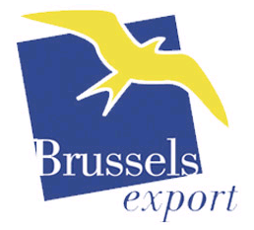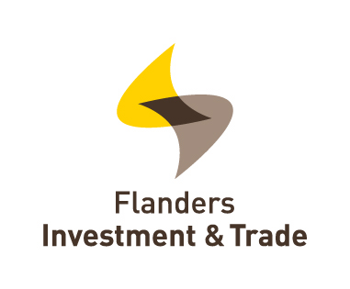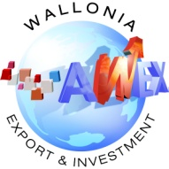
2. Business of Design Week logo
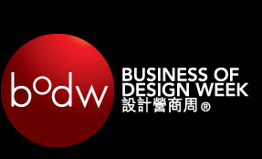

3. Belgian Spirit logo
