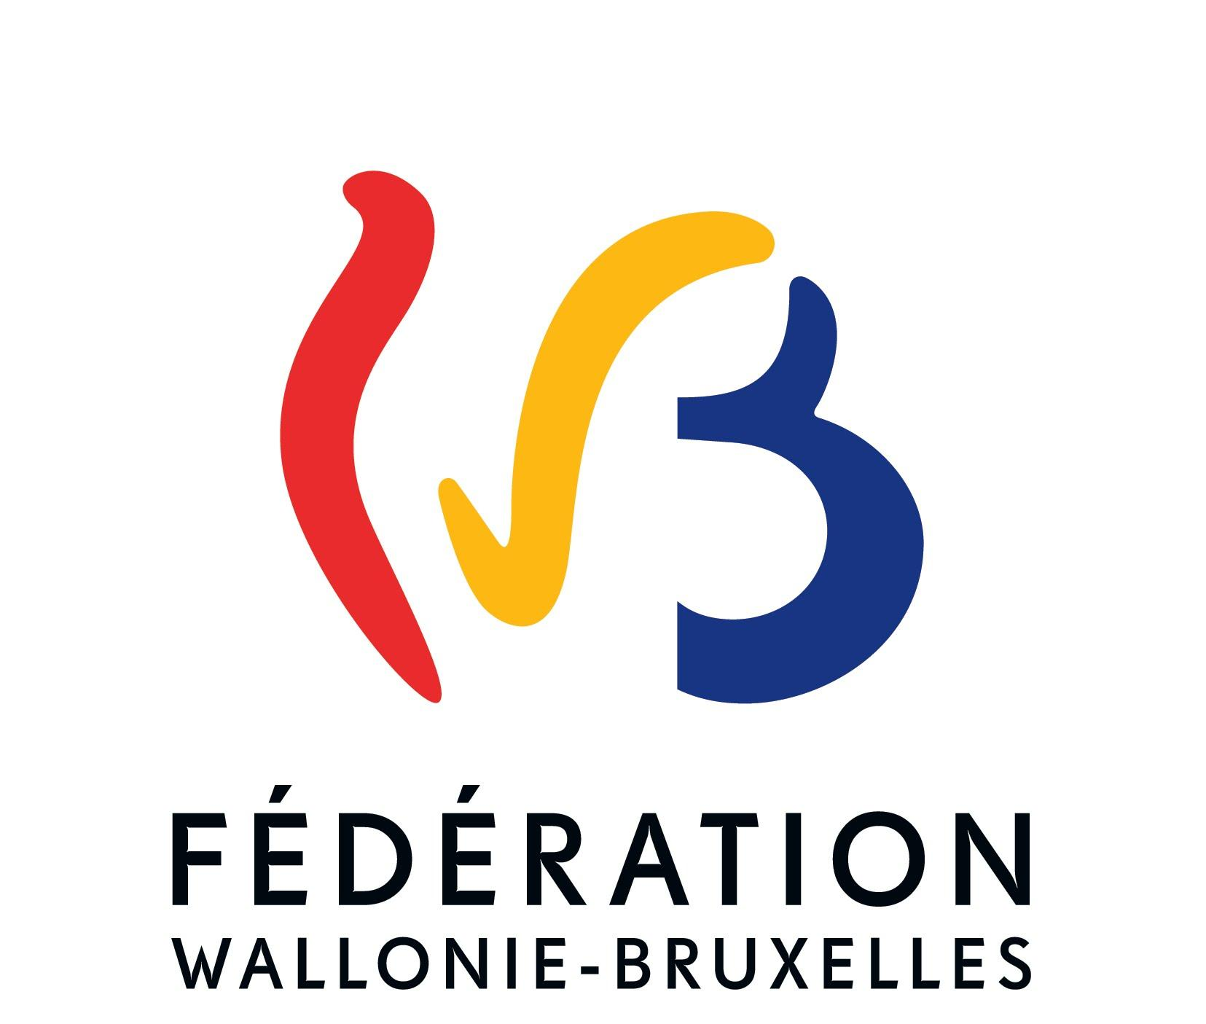
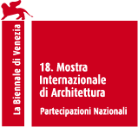

Belgian Pavilion
at the 18th International Architecture Exhibition– La Biennale di Venezia [Venice Biennale]
20 May – 26 November 2023
In Vivo
Curators: Bento and Vinciane Despret

In cooperation with Corentin Mahieu, Juliette Salme, and Corentin Mullender and the producers Permafungi, BC Materials, and Sonian Wood Coop.

The Belgian Pavilion will inaugurate the "In Vivo" project at the 18th Venice Biennale International Architecture Exhibition on Friday 19 May at 3:00 pm, in the presence of the Minister for Culture of the Wallonia-Brussels Federation.

For this edition, the Belgian representation will focus on the exploration of the architect's new relationship with resources.

In "In Vivo", Bento and Vinciane Despret question our system of extractivist production by identifying and developing construction alternatives using materials derived from living organisms and the imagery that accompanies them. Their installation experiments with natural, living materials, including raw earth and mycelium (the vegetative part of fungi) on a large scale, while the Pavilion catalogue explores our future condition in light of this little-known world.

The pavilion will also play host to one or more one-off events so that the curators can broaden their approach through practical experiments (workshops) and/or exchanges (debates).

18th International Architecture Exhibition - La Biennale di Venezia [Venice Biennale]
A major global cultural event for architecture, the Venice Biennale International Architecture Exhibition is held every other year from May to November in the Arsenal and in the national pavilions of the Giardini, under auspices of a general curator who suggests a theme for all the contributions to the Biennale Architettura [Architecture Biennale]. The curator Lesley Lokko (Ghana/Scotland, founder and director of the African Futures Institute) has chosen the concept of "Laboratory of the future" for this 18th edition. As a prelude to the Biennale, she uses a formula that resonates particularly with the imagery developed by the young architects of Bento and the philosopher and psychologist Vinciane Despret in "In Vivo": "More than buildings, forms, materials or structures, it is architecture's ability to alter how we see the world that is its most precious and powerful gift."

Before continuing: We envisage our exhibition as a kind of workshop, a laboratory where architects and practitioners across an expanded field of creative disciplines draw out examples from their contemporary practices that chart a path for the audience — participants and visitors alike — to weave through, imagining for themselves what the future can hold »). That is precisely what the curators of the Belgian Pavilion have set out to do.

An experimental and exploratory project for the Belgian Pavilion
The curators have turned the Belgian Pavilion into a place where alternative resources from the world of construction can be experienced in a sensitive way and where the development process of some of them can be played out.

In the central room, the curators use natural, living materials, experimenting with the installation of panels of mycelium (the vegetative part of fungi) in a spectacular wooden structure (12m long x 6m wide x 6m high) and resting on a floor of raw earth from excavated soil. This provides an opportunity for visitors to experience the sensory, tactile, acoustic and poetic characteristics of these materials. Mycelium, wood and earth all stem from the urban area of Brussels with a view to an ultra-local, sustainable supply. The structure has been designed to be specifically dismantled and its elements will be given a second life in Venice by the local company Re-Biennale, which has been appointed to assemble and dismantle the installation.
With the adjoining rooms dedicated to the process of experimentation and fabrication of the installation created by Bento, the installation is akin to one of the "laboratories of the future" that the curator Lesley Lokko has called for in this 18th edition. It is an open door to another way of creating architecture, based on local resources, which is conducive to the emergence and development of new channels for living materials in Belgium and beyond.

The catalogue, or when the future writes to us
The catalogue is presented as a narrative of anticipation that the advent of the 'mycelocene', a new era characterized by the recognition of sponges and their relationship with humans, and takes as its starting point the proposal made in 2023 by the Bento architects by looking at the possibilities it opens up.
Based on clues and fragments collected by Christine Aventin and Vinciane Despret, this investigation brings together a variety of archives, including correspondence, extracts from mycological and philosophical texts, an anthropologist's field notebooks, and reports by psychologists, historians and experts in therolinguistics (the discipline that studies non-human languages and literature).
The text evokes the entanglement of mycelium networks that are at the heart of the research on materials exhibited at the Belgian Pavilion of the Venice Architecture Biennale in the form of a heterogeneous, non-linear whole that brings together current scientific research and fictional proposals.

Mutual team and conviction
The "In Vivo" team is composed of Bento, founded in 2019 in Brussels by young graduates (2017 and 2019) of the La Cambre-Horta Faculty of Architecture of the (French-language) Free University of Brussels (Florian Mahieu, born in 1993 in Saint-Ghislain, Corentin Dalon, born in 1993 in Lyon, Charles Palliez, born in 1993 in Lille) and Vinciane Despret (born in 1959 in Brussels), doctor of philosophy with a master’s degree in psychology, lecturer at the University of Liège, teacher in ethology and psychology at the (French-language) Free University of Brussels, curator of exhibitions in Belgium and abroad ("Bêtes et hommes" [Beasts and Men] in Paris) and author of numerous works, the best known of which are Au bonheur des morts [Our Grateful Dead] and Habiter en oiseau [Living as a Bird].

Several partners are involved in the development of the exhibition: Corentin Mahieu (born in 1988 in Saint-Ghislain, furniture designer, ceramic craftsman and scenographer, professor at ARTS² (Mons) and at the Haute Ecole Charlemagne [Charlemagne College] (Gembloux), Juliette Salme (born in Liège in 1993, anthropologist at the University of Liège who studies the sensitive dimension of the development of biomaterials and relations between humans and non-humans), Corentin Mullender (born in Brussels, microbiologist, a member of the Brussels non-profit organization, "Fungal Lab", a research laboratory on mycelium).

The curators have also joined forces with PermaFungi (producer of mycelium since 2014), BC matérials (producer of raw earth materials since 2018) and Sonian Wood Coop (producer of wood since 2019) – all three in Brussels.

The credo devised for the Belgian Pavilion is as follows: "How can we rethink architecture in a world of finite resources? [We propose experimenting with enviable alternatives for our territories, our cities, alternatives that would be forged with and from the living beings who inhabit them and are their constituent fabric. These experiments would in essence only extend, expand, and even honour the multiple (and often neglected) arrangements by and between humans and non-humans, the living and non-living [...] The "In vivo" pavilion will provide a time and a place for critical thinking, particularly because questions of responsibility, of taking into account other beings and of justice will be discussed in relation to living and structures. Its strength however will be defined above all by concrete and inventive proposals for an enviable future of living, for which the territory of the Wallonia-Brussels Federation will serve as a starting point for thinking, listing, affirming, confirming, revoking, planning, fantasizing and above all dreaming.”
Bento and Vinciane Despret's application is appended in extenso to this press release.

“In Vivo,” a unanimous choice
The "In Vivo" proposal was selected unanimously by the panel from among the 19 applications that were submitted in response to the call for projects. The narrative was judged to be clear and committed, with an original constructive approach. Moreover, This multidisciplinary team (architects, philosopher, anthropologist, designer and microbiologist) moreover managed to convince the panel particularly because it associated architecture with the field of human sciences and stemmed from the entire territory of the Wallonia-Brussels Federation.

Exhibition and events
The "In Vivo" project will therefore occupy the Belgian Pavilion, built in 1907 by the architect Léon Sneyers and renovated several times since then, for the next six months. It is the second oldest of the Giardini pavilions (after its Italian counterpart) and occupies a prominent position along the main axis of the site. It is plays host alternately to creators from the Flemish Community or the Wallonia-Brussels Federation.

In terms of events, the opening will be on Friday 19 May at 3:00 pm and will be followed the next day, Saturday, 20 May at 3:00 pm, by the "(Re)thinking resources" meeting intended to put a diversity of architects in dialogue on these issues. Other examples of Belgian architectural sectors and projects with a similar approach will be presented around Bento’s specific practice. These projects will be extracted from the latest official almanac of French-speaking Belgium, Architectures Wallonie-Bruxelles Inventaires #4 Inventories 2020-2023, which explores this type of renewed reflection on the nature, provenance, production and quantity of materials used in the building sector.

Sponsor: Wallonia Brussels Federation (Architecture Unit), in partnership with Wallonia-Brussels International
Curators: Bento & Vinciane Despret
With: Corentin Mahieu, Juliette Salme, Corentin Mullender, Permafungi, BC Materials, Sonian Wood Coop
Catalogue FR / EN: Vinciane Despret, Christine Aventin, Juliette Salme et Bento (auteurs), Demeurer en mycelium [Residing in Mycelium], published by Cellule architecture de la Fédération Wallonie-Bruxelles, 2023 / distribution Adybooks / ISBN 978-2-930705-49-1 / 256 pages, 15 €.
The Belgians in Venice
Other stakeholders in Belgian architecture will be present at the Biennale alongside the Belgian Pavilion.
- Exhibited at the Arsenal, these two Belgian projects have been officially selected by general curator Lesley Lokko :
  - At the Arsenal: "Yangambi" by Sammy Baloji: this visual artist proposes an installation on the theme of decolonization and decarbonization. The proposal comprises three chapters: a film shot in Yangambi, located on the banks of the Congo River, in the forest of the Institut National pour l'Etude Agronomique du Congo Belge (INEAC) [National Institute for the Agronomic Study of the Belgian Congo], combining archival and field images, plus two installations: one made up of archives and travel notes from Indonesia (in cooperation with Ghent University) and another based on the proposal for an atmospheric panorama of the Belgian Congo by the Belgian architect Henry Lacoste (project for a pavilion at the Brussels World Fair in 1935). The statement runs as follows: 'This project seeks to explore the tenants of tropical architecture by focusing on the architectural ruins left in the middle of the voracious forest, while analysing the corporeal state of these remnants of Belgian colonialism and how they have influenced the dematerialization and relocation of the pre-colonial social systems of these territories [...] A voice from the past is added to the mix, namely that of Panda Farnana, a remarkable character who would sow the first seeds of independence, be the first Congolese to complete his higher education in Belgium and work as a researcher in climatology and agriculture in Eala, Congo."
  - “Broader boundaries” by BDR Bureau (IT) and carton123 architecten (BE): the architects propose an exhibition of models which approach, through different scales, the theme of Coexistence. The subject is nourished by a real project: the Kappaert school campus (hosting a specialized school, artistic spaces and summer recreational activities) which fits into a heterogeneous built environment characterized by underused public spaces and a cemetery which will disappear over time. The project is defined by an ambiguity between the dissolution of borders and the creation of borders, in order to define protected spaces for children with forms of autism. Architects are working to translate this ambiguity into built form. A line can be an insurmountable border depending on the gaze of the person looking at it. A separation can accommodate a transition zone. A pen can become an area where you can stay. The whole design is governed by the need to return a clear understanding of the space, an essential condition for the place to be fully understandable for all users. The exhibition presents the project from this point of view through models, fragments of "borders" at different scales, visual anchor points. The processes of collaboration between architects and with users are also exposed.
- In "Off" (May 17, 6 p.m., Fondamenta Sant'Anna, 996) : "Inventories #4" by ICA-WB (Institut Culturel d'Architecture Wallonie-Bruxelles / Cultural Institute of Architecture Wallonia-Brussels): the related launch event of the new volume of Architectures Wallonie-Bruxelles Inventaires #4 Inventories 2020-2023 will assume the form of an exhibition in Venice that open on Wednesday, 17 May as of 6:00 pm, the day before the opening of the 18th Architecture Biennale. The publication will be echoed during the event "(Re)thinking Resources" scheduled at the Belgian Pavilion on 20 May at 3:00 pm.
- In "Off" (places and times to be specified): presentation events and exchanges with the actors of the independent Belgian architecture magazine Accatone.
- In “Off” (19 May at 5.30 pm, Paradiso): crossed conversations around the international launch of the Flanders Architecture Book n°15 (2022).
For more information on the programmes, go to www.belgianpavilion.be
Contacts
Forum Press Communication
Press:
ki@forum-communication.be; ns@forum-communication.be
+32475554961 ; +32475797701

