Press Information Belgian Spirit - Architecture

Belgian Spirit is an initiative of the three Belgian Regions of Brussels, Flanders & Wallonia. It was set up in 2011. Belgian Spirit promotes Belgian architecture, design and fashion in Asia through Business of Design Week (BoDW) in Hong Kong and other events. The goal is to create and develop long‐term collaborations between Belgian designers and their Asian counterparts and clients.
As partner country of BoDW 2013 Belgian Spirit will organize a series of events and activities in December 2013.
For our architectural track, Belgian Spirit takes part in the Bi-City Biennale of Urbanism / Architecture 2013 (UABB) with our “XX Models Young Belgian Architecture” exhibition. Co-curated by Marie-Cécile Guyaux and Iwan Strauven, the exhibition will show the work of twenty young Belgian architect firms through some of their first public projects.

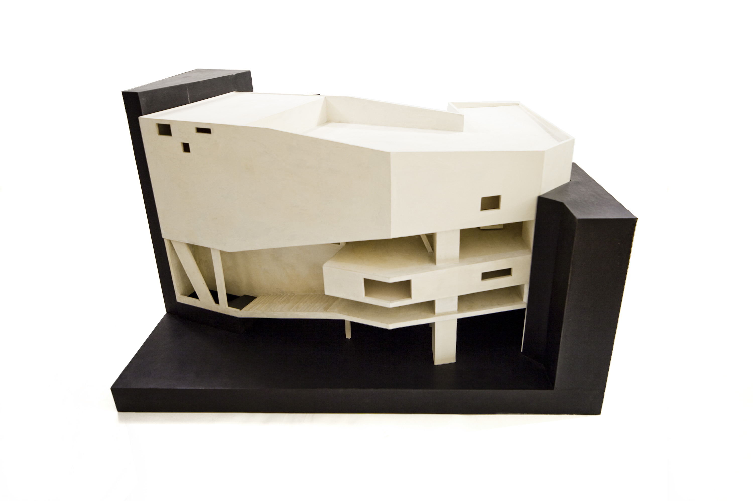
V+ © Jeroen Verrecht

XX Models Young Belgian Architecture

The exhibition presents 20 scale models, each representing a project of a public or collective nature built by an emerging Belgian architectural firm in the last ten years. All 20 architects were invited by A+ Architecture in Belgium / Bozar Architecture to the Centre for Fine Arts in Brussels between 2008 and 2012 to give a lecture on their project, their first major commission at the time. Their model was subsequently exhibited for one year in this magnificent building designed by Victor Horta.

The location of most of the exhibition projects is Belgium, which forms an endless conurbation as one of Europe’s most densely populated countries. In this context of continuous urban sprawl, political, cultural, social and linguistic borders serve in place of vanishing urban boundaries. The result, especially in Belgium, is a complex arena of shared territories and landscapes. Based on its public or collective dimension, each project bears witness in its own way to this specific urban condition.

The exhibition also explores the idea of the model as architectural project in its own right. Each one is accompanied by interviews with the architects about their building and how they have represented it. This is because, besides its political, administrative or social aspects, architecture is also concerned with questions of form, space, dimension, scale, materials, conception methods and, of course, representation.

The co-curators of the exhibition are Iwan Strauven and Marie-Cécile GUYAUX.
Iwan Strauven (°Brussels, January 3rd, 1974) is Professor at the Architecture Faculty of l’Université libre de Bruxelles (ULB) and curator of the architectural programme at the Centre for Fine Arts in Brussels (BOZAR ARCHITECTURE / A+ ARCHITECTURE IN BELGIUM). He was trained as an architectural engineer and developed an activity as an architectural critic: author of a monography on the Bourgeois brothers and a publication on Alfred Hardy, he publishes regularly in the architectural reviews Architecture d’Aujourd’hui (F), Abitare (I), Il Giornale dell’Architettura (I), de Architect (NL) et la revue belge d’architecture A+. At ULB he is head of a design studio, teaches history of 20th century urban planning and is finishing his PhD on the work of the modernist architect Victor Bourgeois.

Marie-Cécile Guyaux (°Brussels, December 21st, 1982) is Assistant Professor at the Architecture
Faculty of l’Université Libre de Brussels (ULB) and a Project manager for the architectural programme at the Centre for Fine Arts in Brussels (BOZAR ARCHITECTURE / A+ ARCHITECTURE IN BELGIUM). She was trained as an architect and developed an activity as an architectural critic: a.o. co-editor of a series about Young Architectures (A16 publishers) and a publication on Reflexivity in Architecture (La Lettre Volée ed.), she published articles in A+Belgian Architectural Review.

Participating firms and projects:

- Bureau vers plus de bien-être (V+), Sauvenière Cinema in Liège (BE)
- Julien De Smedt Architects, Mountain & VM dwellings in Copenhagen (DK)
- 360 Architecten, Vlerick Business School campus in Leuven (BE)
- Dierendonck Blancke Architecten, Cultural centre in Avelgem (BE)
- Architecten De Vylder Vinck Taillieu, Ballets C de la B & Lod, Dance and theatre studios in Ghent (BE)
- NoAarchitecten, Petrol, Electric Infrastructure in Antwerp (BE)
- AgwA, Métal, Collective infrastructure & social housing in Saint-Gilles, Brussels (BE)
- Bulk architecten, Warehouse in Blankenberge (BE)
- Office Kersten Geers David Van Severen, Kortrijk Xpo Exhibition Hall & Master Plan in Kortijk (BE)
- Matador, Maison Folie, Cultural centre in Mons (BE)
- HUB, Art Basics for Children, Cultural studios for kids in Schaerbeek, Brussels (BE)
- Urban Platform Architects, Retail headquarters in Seneffe (BE)
- B612 Associates, Dolez, Collective housing in Uccle, Brussels (BE)
- URA, KOP, Warehouse and offices in Puurs (BE)
- Planners, Zwaneberg, Cultural centre in Heist-op-den-Berg (BE)
- Puls architecten, De Drei Heeren, Social housing in Antwerp (BE)
- Geert De Groote Architecten, Eden, Public pavilion in Ghent (BE)
- A229, ITP, Technical school in Court-Saint-Etienne (BE)
- Bureau d’architecture Ledroit Pierret Polet, Cygne-Digues, Social housing and neighbourhood facilities in Ixelles, Brussels (BE)
- NU Architectuuratelier, C-mine expeditie, Tourist centre in Genk (BE)

XXModels is a production of BOZAR and A+ Architecture in Belgium. It is a platform for everything connected with architecture in Belgium. Its mission is to stimulate debates and reflection about architecture. For 40 years A+ has been the main architectural review in Belgium. Since 2006, in association with Bozar Architecture, A+ has organized exhibitions, lectures and debates with some of the most renowned Belgian and international architects. Its programme also goes beyond the national borders by engaging in co-production with internationally renowned centres for architecture such as COAC in Barcelona, Arc-en-Rêve in Bordeaux and the Whitechapel Art Gallery in London.

To integrate XXModels into the Belgian Spirit project a collaboration between BOZAR/A+ and Belgian governmental organizations has been set up.

More details on the exhibition

Belgium: one diffuse city

Belgium, with a population of 11 million people, is one of Europe’s most densely populated countries. Its territory is almost entirely urbanized and it possesses the world’s densest road and railroad. Indeed, one could perceive Belgium as one large diffuse city without real geographical, landscape or typological borders.
Moreover, this characteristic can also be seen across the national border, since Belgium is located in the centre of other major European conurbations like the region Tournai (B) -Lille (F) - Kortrijk (B) or the Euro-region Meuse (B-F) - Rhine (G).
In contrast with its physical characteristics, Belgium is a particularly fragmented country in terms of politics, culture, language and governmental administration. It hosts three different linguistic and cultural communities (Flemish, French and German-speaking people) and is ‘divided’ by a linguistic border. Belgium counts no less than four governments and many different levels of local administrations.
Moreover, Belgium hosts some of the main European institutions and the headquarters of NATO. As such, Belgium possesses a peculiar mix of political, cultural and linguistic territories. This fact has had a profound effect on our architecture and our approach to urban design, even though the existence of these territories and their respective borders are not necessarily perceived physically.

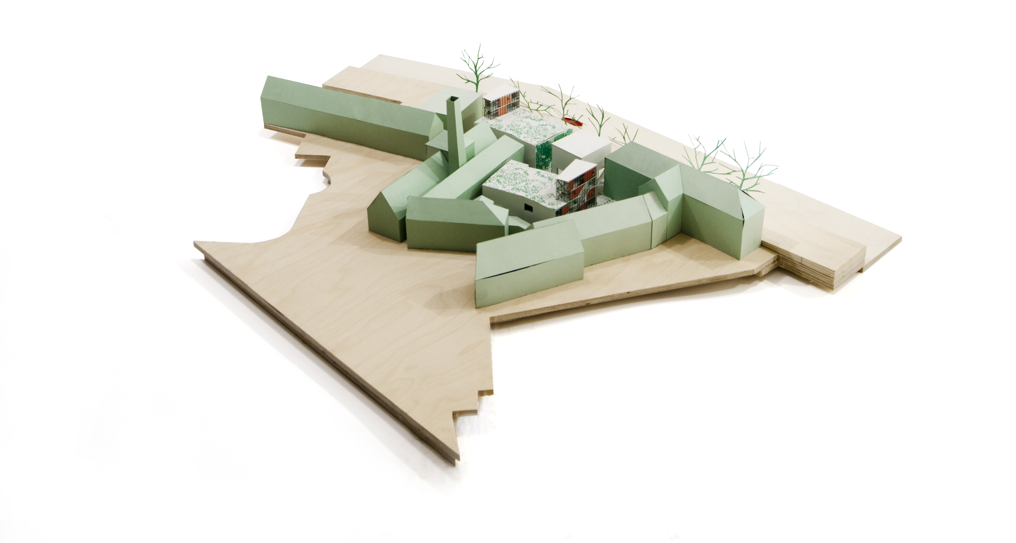
Architects de Vylder Vincke Taillieu © Jeroen Verrecht

XX Models: the expression of a diffuse city
It is in this context of a nation-wide diffuse city that the exhibition XX Models takes place. Through a selection of 20 collective and public projects, it shows how architecture can, on the one hand, be an expression of this diffuse city; and on the other hand, how each of these projects plays with the invisible borders that exist throughout Belgium by unveiling and emphasizing them, and then going beyond them.
Bozar Architecture (Centre for Fine Arts, Brussels) and A+ (Belgian Architectural Review) are the only cultural organisations dedicated to architecture that, because of their specific status, transcend political, cultural and linguistic borders. In 2008 they initiated a programme dedicated to budding architects by inviting, on a bi-monthly basis, a young architect firm to present one of their first public or collective projects – most architectural work in Belgium is private individual housing.

Over the years Bozar Architecture and A+ have been introduced to a widely varied number of such projects. They are located throughout the Belgian territory and in different contexts, such as port zones, city centres, outlying districts and rural areas. In these different places these works of architecture have developed, each in their own fashion, a singular relation to the invisible borders inside which they are located and with which they have had to work.

The Community Centre Spikkerelle by DierendonckBlancke Architects, for instance, with its contemporary language in the heart of a traditional and mainly residential urban area, asserts itself as a strong case in point on the linguistic and cultural border that divides the country. We can also mention Maison Folie, a project by Matador, which is one of the elements of a French-Belgian cross-border cultural network called Maison Folies.

On the scale of districts or neighbourhoods we see the projects of Ledroit-Pierret-Polet or V+, who create ‘breaches’ inside traditionally private city blocks so as to create public space for inhabitants to enjoy.

On the architectural scale, the existence of borders becomes a tool for Office Kersten Geers David Van Severen to frame the chaotic development of a set of exhibition halls that were constructed with a long-term vision.

When put in a broader context these projects show us that the notion of urban borders can be used as a tool of inspiration to create architecture that both embraces and does away with these borders.

XX Models: the exhibition

The exhibition consists of twenty architecture models mainly realized after the construction of the projects and displayed on a white and unifying base. It should be noted that these models are architectural projects in their own right.

Indeed, beyond political, administrative or social dimensions architecture covers world-wide questions regarding form, space, dimension, scale, materials, conception methods or even space representation.

XX Models intends to emphasize these important themes in an international and multi-lingual context.

Finally, these twenty models are a great opportunity to see the work of a wide variety of young Belgian architectural firms who work within the context of a diverse set of urban borders.

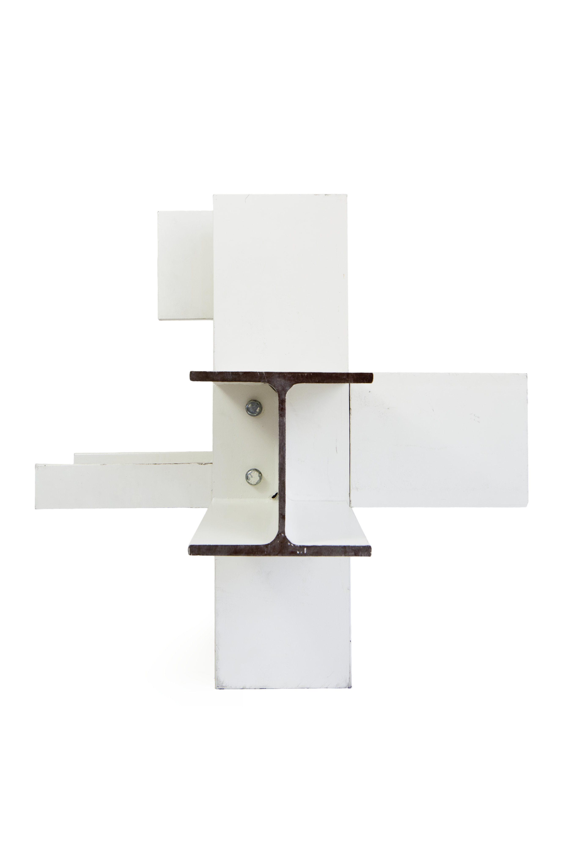
Office Kersten Geers
David Van Severen © Jeroen Verrecht

Bi-City Biennale of Urbanism\Architecture
The 5th edition of the Bi-City Biennale of Urbanism\Architecture (UABB) (formerly called “Shenzhen & HongKong Bi-city Biennale of Urbanism\Architecture) will open in Shekou in Shenzen on the 6th of December and will go on until the 28th of February.
This biennale will be delivered by two curatorial teams, consisting of Team Ole Bouman and Team Li Xiangning+ Jeffrey Johnson. Ole Bouman will act as Creative Director. He will collaborate with Stylepark on Urban Labs. Meanwhile, Li Xiangning and Jeffrey Johnson will be the Academic Directors. It will be the first time that the UABB uses this curatorial framework.
The theme
The theme of the 5th UABB is URBAN BORDER which has been developed under the precondition of pluralistic values. It emphasizes the diversity, differences and individuality ignored, even hidden, by mainstream trends and homogeneity inherent in speedy urbanization. The curatorial teams will develop the Biennale proposal according to this theme. From this edition, UABB Shenzhen and Hong Kong will use the same theme and gradually step forward to the goal of “One Biennale”.
The location
Shekou is an industrial zone in Nanshan District of Shenzhen, which is the experimental field of reform and opening-up in China. The main venues are the former YAOPI Float Glass Factory (Venue A) and the Old Warehouse at Shekou Ferry Terminal (Venue B) that both belong to China Merchants Shekou Industrial Zone Co., Ltd , they will be linked by public transportation and greenways. The Creative Director, Ole Bouman, will be in charge of Venue A, the Manifesto/Prospective Venue, while the Academic Directors, Li & Johnson, will present Venue B, the Documentary/Retrospective Venue. In 2013, the Shekou Industrial Zone will welcome its renewal and upgrading. It will provide UABB with an opportunity to witness a new chapter of urbanization in the Pearl River Delta (PRD) of China. Some Biennale activities will also be organized at other sites in the city.
The curators
Creative Director Ole Bouman is a Dutch architecture professional, author and educator. He has long been active in the fields of global architecture and urbanism. He was the Director of The Netherlands Architecture Institute until January 2013 and has extensive international teaching experience. He has taught and regularly lectured at internationally famous universities and diverse cultural institutions. He is a seasoned curator with exhibitions at the Venice Architecture Biennale and the Sao Paulo Biennale. His excellent exhibition project Housing with a Mission, Dutch and Chinese architects’ designs for the ants tribe in 2011 UABB*Shenzhen won the Organizer Committee Award. Stylepark is a leading international platform for architecture and design. As curators, consultants and commentators, Stylepark mediates between architects, planners and urbanists.

The Academic Directors are Li Xiangning from China and Jeffrey Johnson from United States. Mr. Li teaches as a Full Professor in the College of Architecture and Urban Planning, Tongji University, and is a renowned scholar of Chinese contemporary architecture theory, criticism and curation. Being a stellar academic, he has been invited to lecture at universities such as Harvard and Princeton. He was the Chief Curator of the Hainan Sanya Design Biennale, and curated exhibitions at the Milan Triennale and Chengdu Biennale. Jeffrey Johnson is the founder and director of China Lab at Columbia University. Both Mr. Li and Mr. Johnson have participated in UABB*Shenzhen.
About Bi-City Biennale of Urbanism\Architecture (UABB)

Urbanism \ Architecture Bi-city Biennale (UABB) is the only biennial exhibition in the world at present that focuses on URBANISM AND URBANIZATION. UABB established by Shenzhen in 2005, is co-organized and jointly held by Hong Kong and Shenzhen since 2007, which share intimate interactions and characteristics related to the rapid urbanization of the Pearl River Delta, where they are based; with an emphasis on global urban issues demonstrated through visual presentations, to encourage interaction and communication with the wider public, and possesses features that are international, avant-garde and of public benefits.
Practical Information
Venue: Venue B, Shenzhen
Dates: 06.12.2013 > 28.02.2014
Opening: 06.12.2013 > 08.12.2013
Curators: Marie-Cécile Guyaux, Iwan Strauven
Coproduction: BOZAR ARCHITECTURE, A+ Architecture in Belgium
In the framework of: Belgian Spirit
An initiative of: AWEX, BI&E, FIT
Supported by: WBA, Design Vlaanderen
Platinum sponsor: Ice-Watch
Bronze sponsor: Extremis
Preferred partners: Hoet & Hoet - Demain,il fera jour - Hotel Renaissance Harbour View, Hong Kong - Exsan

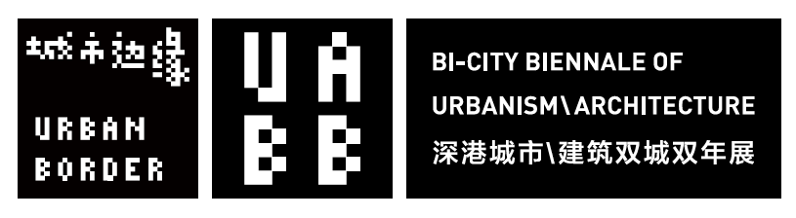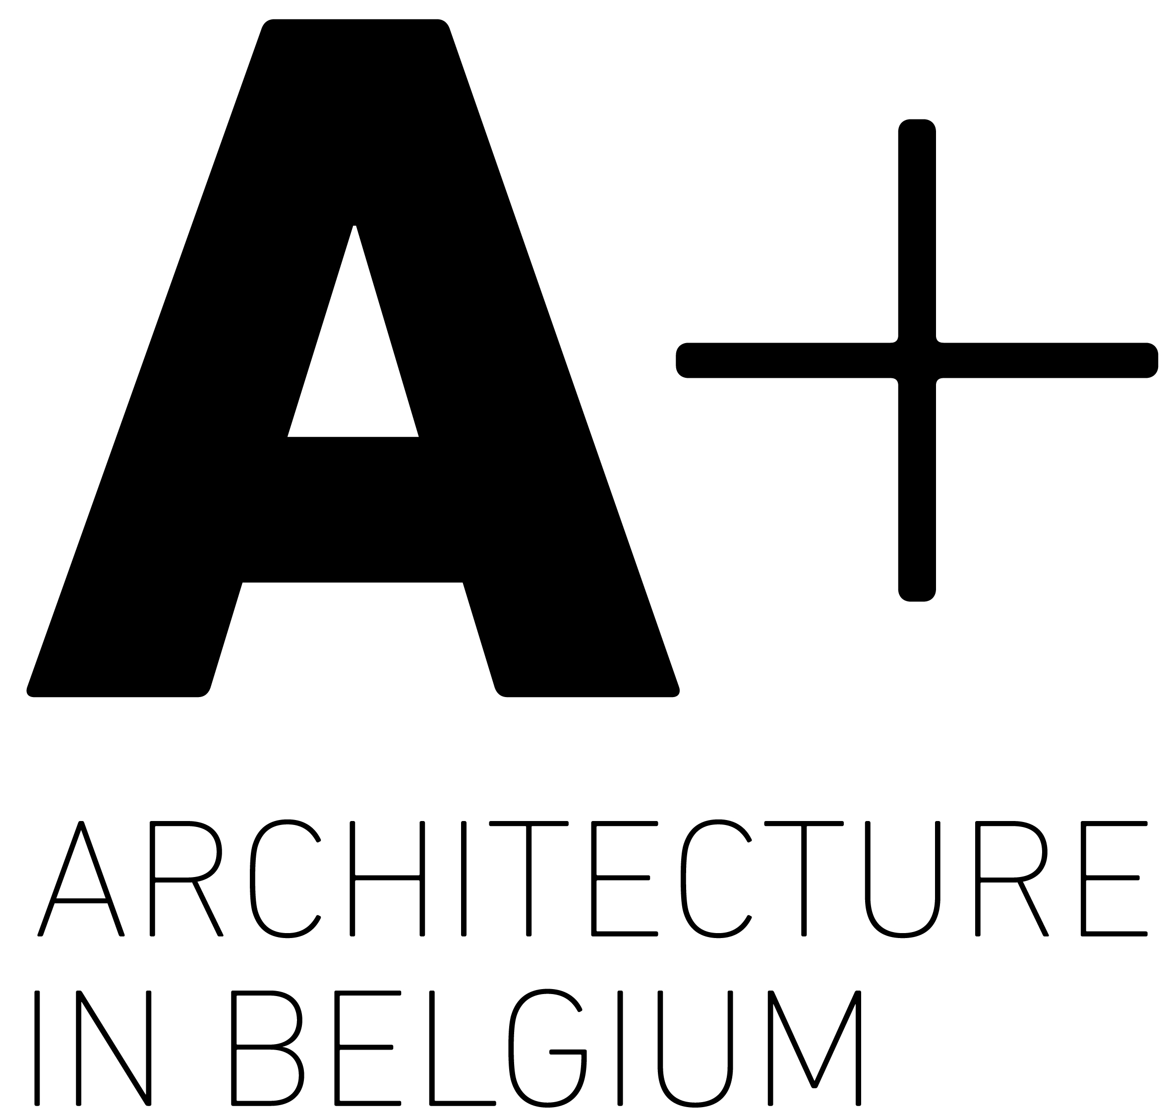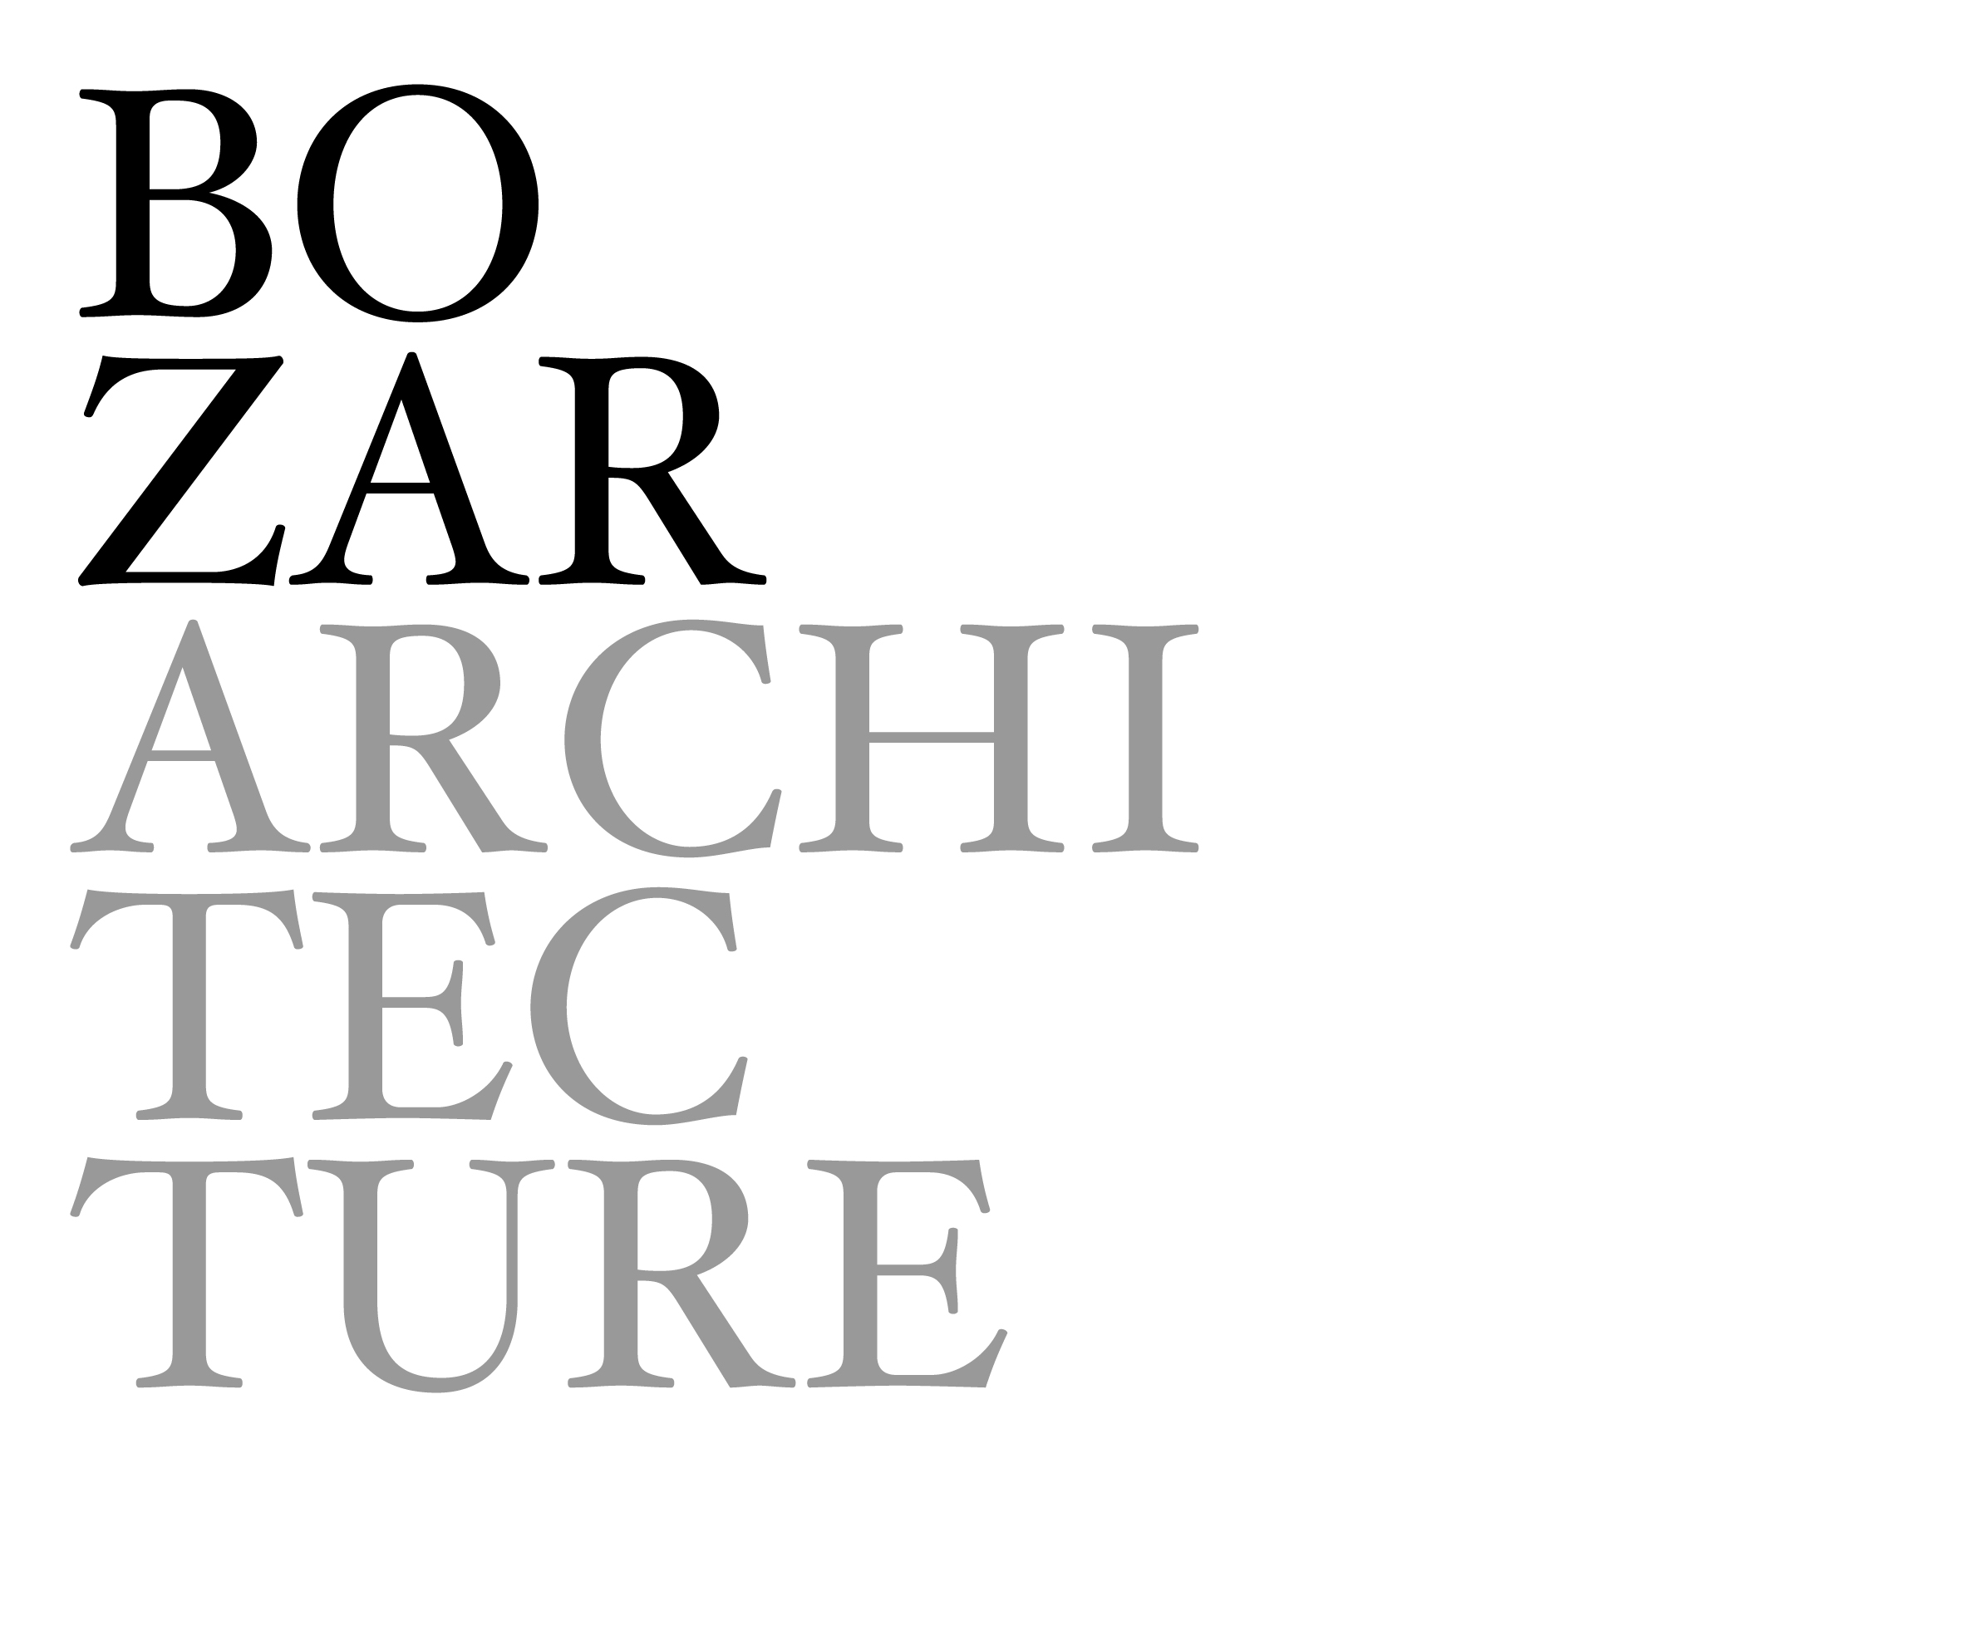

BELGIAN SPIRIT

Belgian Spirit is an initiative of the three Belgian Regions of Brussels, Flanders & Wallonia. It was set up in 2011. Belgian Spirit promotes Belgian architecture, design and fashion in Asia through Business of Design Week (BoDW) in Hong Kong and other events. The goal is to create and develop long‐term collaborations between Belgian designers and their Asian counterparts and clients.  www.belgianspirit.be | 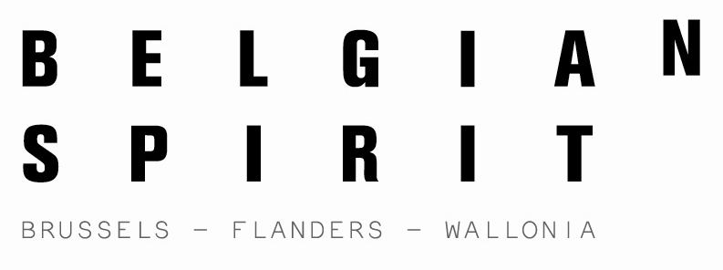

PARTNERS

The Wallonia Foreign Trade and Investment Agency (AWEX) is the government agency of the Belgium region of Wallonia in charge of foreign trade promotion and foreign investment attraction. As a foreign trade agency, AWEX carries out a mission of promotion and information for the benefit of both Wallonia and the foreign business community. As a foreign investment agency, AWEX – via its Office for Foreign Investors (OFI) – has an overall responsibility for the attraction of foreign investment in Wallonia.  www.awex.be | 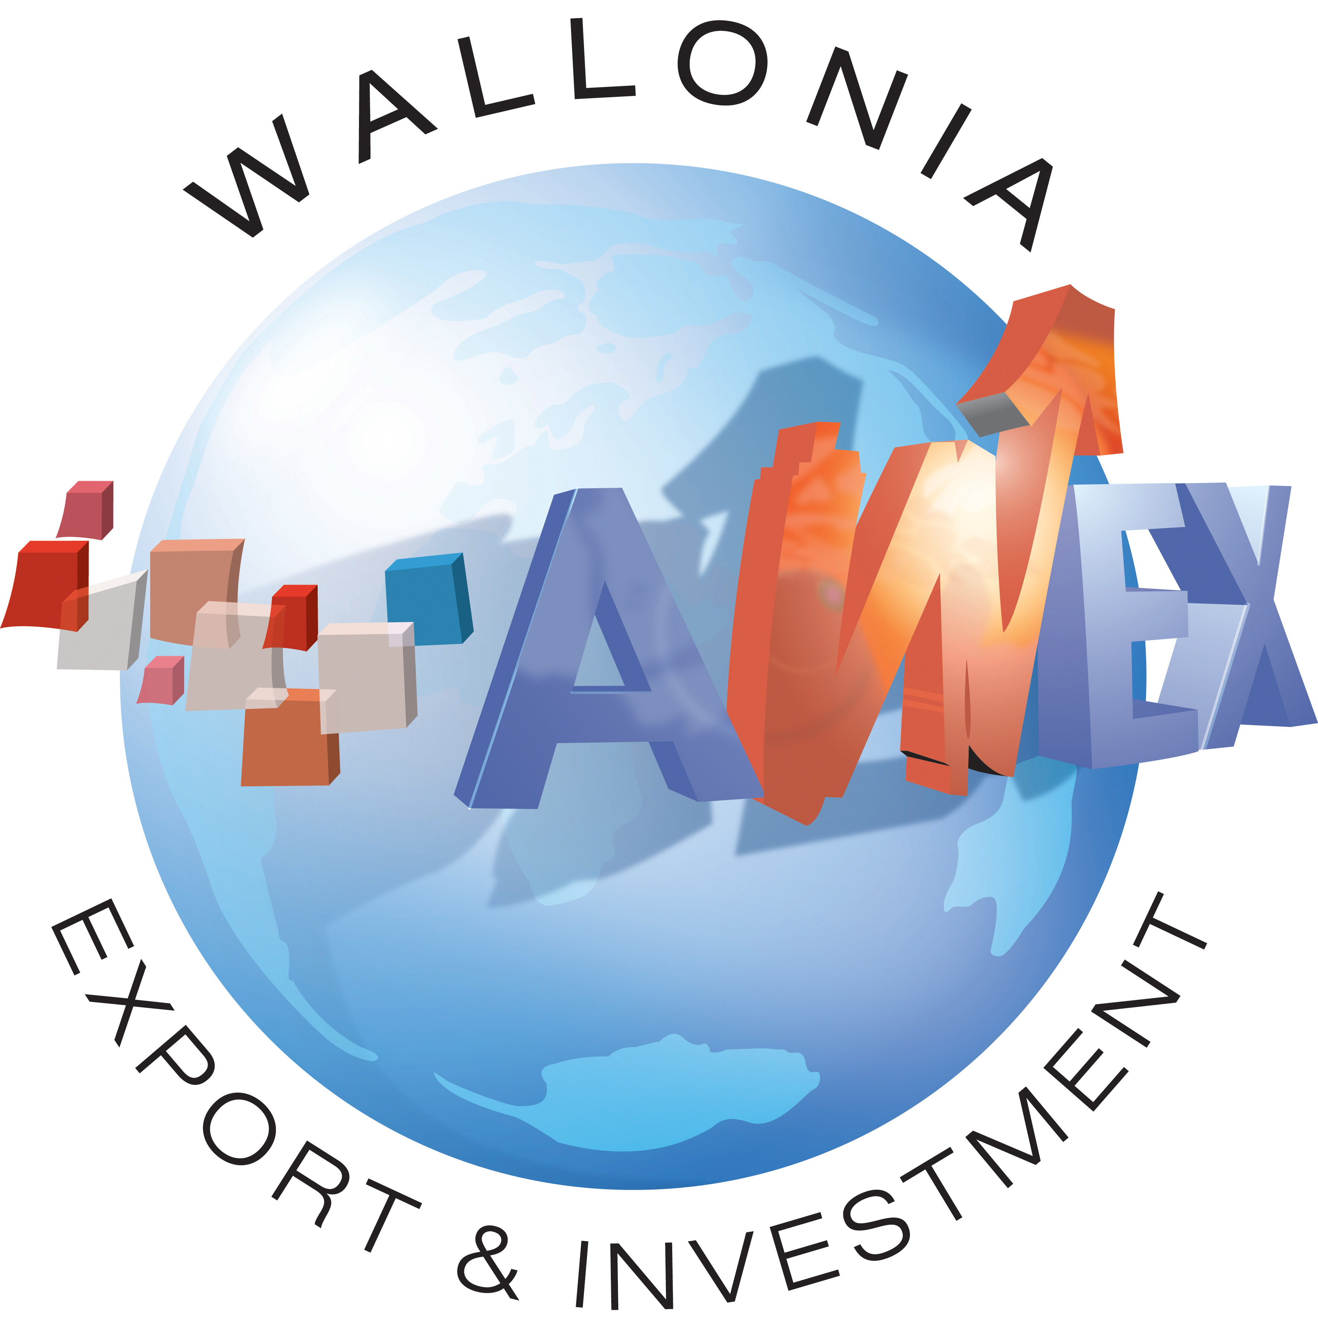
Brussels Invest & Export (BI&E) is a unique boost for Brussels-based and foreign companies. It helps Brussels exporters to find their way to new markets and acts as a one-stop shop to welcome foreign investors in Brussels. Brussels Invest & Export is the foreign trade and foreign investments service of the Ministry of the Brussels-Capital Region.  www.invest-export.irisnet.be | 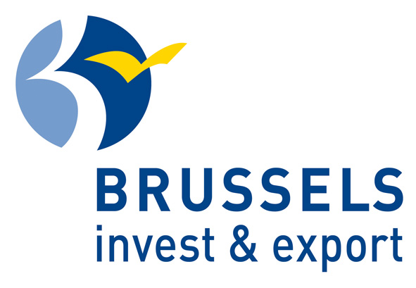
Flanders Investment & Trade (FIT), the Flemish Agency for International Entrepreneurship and Investment Promotion, promotes Flanders as a place of business for foreign companies and supports Flemish companies in international entrepreneurship. FIT’s strongest asset is its national and international network.
www.flandersinvestmentandtrade.com

Design Flanders promotes contemporary, high quality and innovative design in Flanders. The organization is part of Enterprise Flanders. Design Flanders guides and stimulates primarily designers in Flanders into building their business. It coaches businesses and governments who want design to be used in their operations. By doing this Design Flanders adds to the success of the new Industrial Policy of the Flemish Government.
www.designvlaanderen.be

Wallonie-Bruxelles Architectures (WBA) is a service deigned to promote the development and international recognition of architects (and related professions such as planners, landscape designers, specialized photographers, etc.) working in Wallonia and in Brussels.
www.wbarchitectures.be

Flanders Fashion Institute encourages
entrepreneurship within the fashion industry in
Flanders, teaches designers about business skills and promotes Flemish fashion in Belgium and abroad. FFI is part of Flanders District of Creativity.
www.ffi.be

The MAD Brussels - Fashion and Design Center - a new project set up by the City of Brussels and the Brussels-Capital Region with support from the European Objective 2 programme and the European Regional Development Fund (ERDF) - is aimed at promoting the economic development of the fashion and design industries in Brussels. To that effect, several actions are undertaken.  www.madbrussels.be | 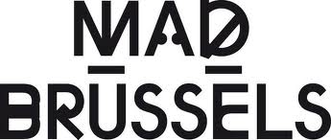
Created in 2006, Wallonie-Bruxelles
Design/Mode (WBDM) is a governmental
agency for the promotion of design and fashion, which aims to increase the international reputation of designers from Wallonia and Brussels. Through a constant participation in major tradeshows, exhibitions and conferences, WBDM’s mission is to increase networking and business opportunities for Belgian design and fashion talent in the international market.
www.wbdm.be

PLATINUM SPONSOR

Created in 2006, the Belgian brand Ice-Watch has become a core brand in the market over the last six years, perfectly in line with the trend in consumption and the social phenomenon of change. The Ice-Watch timepieces can now be found in all five continents, in more than 110 countries and more than 12,000 points of sale. Beside the vibrant and colourful Forever collections, the range is continuously evolving with innovative collections, including “ICE”, a new minimalist line, Ice-Chrono and Ice-Star. With each collection, Ice-Watch continues to offer unique design and ever more intense colours. The iconic “BeCubic” packaging always aligned with the collections remains across all styles within the Ice-Watch range. The cubic shape provides a strong visual as part of the brand’s identity criteria. Furthermore, in line with the brand’s commitment to innovation and quality, all timepieces produced are 10 ATM water resistant.
www.ice-watch.com

BRONZE SPONSOR

Extremis is a furniture range with a vision and a mission. A brand that breathes innovation. Extremis does not aspire to simply put beautiful furniture on the market. They make “tools” that make life better. More pleasant. These tools must always be functional. And above all always better than the products already available. In Extremis’ designs every single aspect is the fruit of careful consideration.
Extremis is much more than just a furniture range: it’s a lifestyle that brings people together. That lets them enjoy life together. The slogan ‘Tools for togetherness’ has not been chosen randomly.
For Extremis, assembly, quality control, and distribution are also of major importance. Only by paying the necessary attention to these stages, the products reach the customer in optimum conditions.
Although they mainly focus on the outdoor furniture market, several of its products have turned out to be perfectly at home indoors as well.
Right from the start, Extremis has resolutely chosen to focus on export. Today exports account for 78% of the total turnover.
Several designs are patented proving that Extremis is not only about design but also and primarily about technological innovation. “Design follows function” is much more than just a slogan for Extremis.
www.extremis.be

PREFERRED PARTNERS

www.demainilferajour.com
www.exsan.be
www.hoet-hoet.eu
renaissance-hotels.marriott.com | 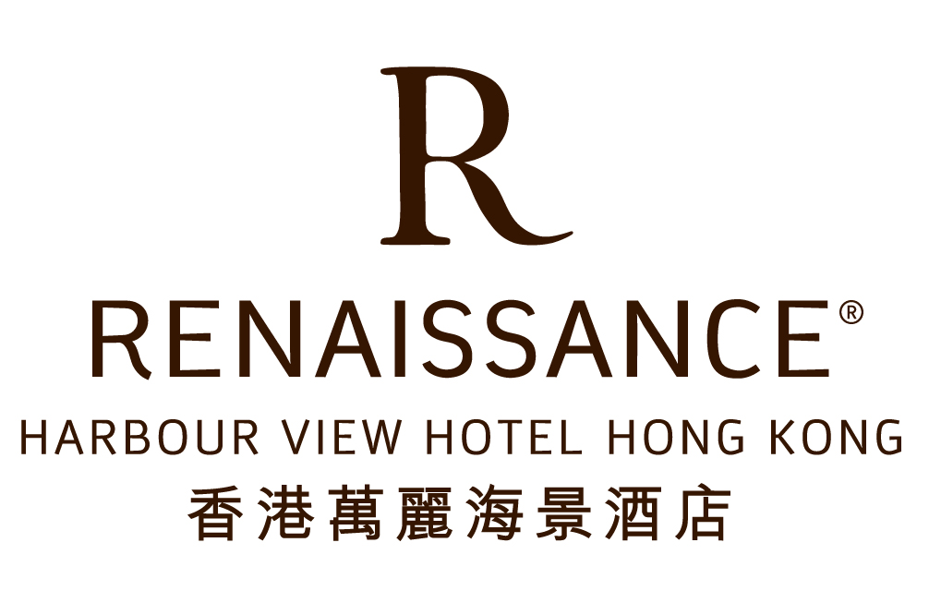

PRESS CONTACTS

AWEX
In Belgium:
Arnaud Collette
a.collette@awex.be
+32 (0)476 570 130

In Hong Kong:
Xavier Schreiber
hongkong@awex-wallonia.com
+852.2537.5762

Brussels Invest & Export
In Belgium:
Florence Ortmans
fortmans@mrbc.irisnet.be
+32 (0)2 800 40 53

In Hong Kong:
Siegfried Verheijke
siegfried.verheijke@fitagency.com
+852.2523.2246

FIT
In Belgium:
Bart Matheï
bart.mathei@fitagency.be
+32 (0)2 504 88 79
+32 (0)473 366 975

In Hong Kong:
Siegfried Verheijke
siegfried.verheijke@fitagency.com
+852.2523.2246

Wallonie-Bruxelles International
Dominique Lefèbvre
d.lefebvre@wbi.be
+32 (0)477 400 537

GENERAL CONTACT

Myriam Cops

ROSCOP
International Project Management & Consultancy

+32 479 261 470
Skype ID myriam.cops
myriam@roscop-consultancy.com

PR

Pamela So

WEBER SHANDWICK

+852.2533.9916
pso@webershandwick.com

